NC054H2053-12×DIN49440 Specification
Date: 2014-07-02 No: PLBK0311407001
Customer |  | BKT
Product Name |  | Factory Part No. |  |  |  |  |  |  | Customer Part No.
NPM |  | NC054H2053-12×DIN49440
Main Functions |  | Details
Monitor |  | Total load current for each phase
 |  | Input Voltage
 |  | Total energy consumption（kWh）for each phase
 |  | Power Factor
 |  | Total power(kW) for each phase
 |  | On/Off state of each outlet
 |  | Temperature and Humidity state （Max. 2 T/H sensors on standard version）
Control  and configure |  | Switch on/off individual outlet
 |  | Set the threshold of total load current for each phase
 |  | Set the delay of outlet sequential switching
 |  | Clear the total energy consumption(kWh) for each phase
 |  | Set the threshold of temperature and humidity
 |  | Set the work mode (master or slave)
 |  | Support external WIFI
Keep the  former state |  | Keep the former state of individual outlet after reset
Alarm | User defined alarm | Set the threshold of total load current for each phase
Alarm | User defined alarm | Set the threshold of temperature and humidity
Alarm | System default alarm | When overload occurs
Alarm | System default alarm | When Threshold of temperature and humidity is exceeded
Alarm | Alarm method | LCD displays the alarm and buzzer sounds
Alarm | Alarm method | Web interface show the value exceeded in red
Alarm | Alarm method | Send E-mail to administrator automatically
Alarm | Alarm method | SNMP sends trap alarm information
Alarm | Alarm method | Logical port outputs level signal
Alarm | Alarm method | SYSLOGS
Log record |  | Record and save the operating and alert information, graphic record of electric parameters and environment which can be exported.
Daisy chain |  | Support Daisy-chain
Central management |  | Support central management of N units via CLEVER Manager software
User management |  | Different user permission configuration
 |  | Outlet Alarm permission configuration
 |  | Set the permission to clear the energy consumption(kWh)
Accessing method |  | Web based, support multiple browsers like IE, Google, Firefox etc.
 |  | SNMP (V1/V2C/V3)
 |  | Telnet
 |  | Serial Access
 |  | RADIUS
Input/output

输入/ 输出特性
Input |  | Rated input voltage |  |  |  | 400V~ 50/60 Hz
 |  | Input terminal type |  |  |  | IEC60309 3P+N+E 32A plug
 |  | Cable specification |  |  |  | 5×6.0mm²；
 |  | Cable length |  |  |  | 3M
 |  | The max input current |  |  |  | 3×32 A
Output |  | Socket |  |  | DIN 49440 + LED |  |  | Rated current |  | 16A | Outlet quantity |  | 12
 |  | Socket |  |  | IEC320 C19 + LED |  |  | Rated current |  | 16A | Outlet quantity |  | 8
 |  | Rated output voltage |  |  |  | 250VAC
Dimension |  | Product size |  |  |  | L×W×H = 1732×66.6×44.4mm
Optional fittings
Temperature/humidity sensor |  |  |  | Door sensor |  |  | Smoke sensor |  |  |  |  | Water sensor
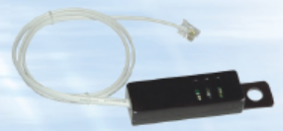 |  |  |  | Customized solution, must ask before production.
PDU drawing on next page
PDU overview
Phase A
Phase B
Phase C
Toll-less mounting
1728mm
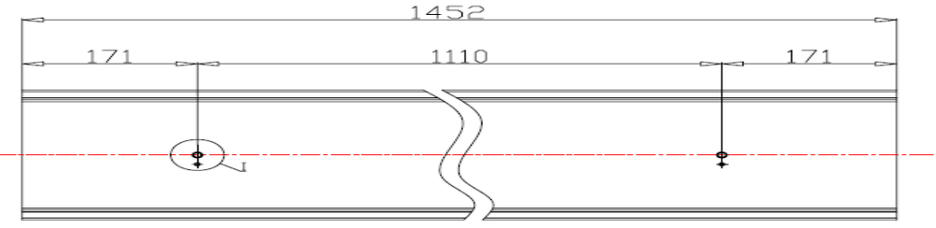
1556mm
86mm
86mm

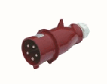
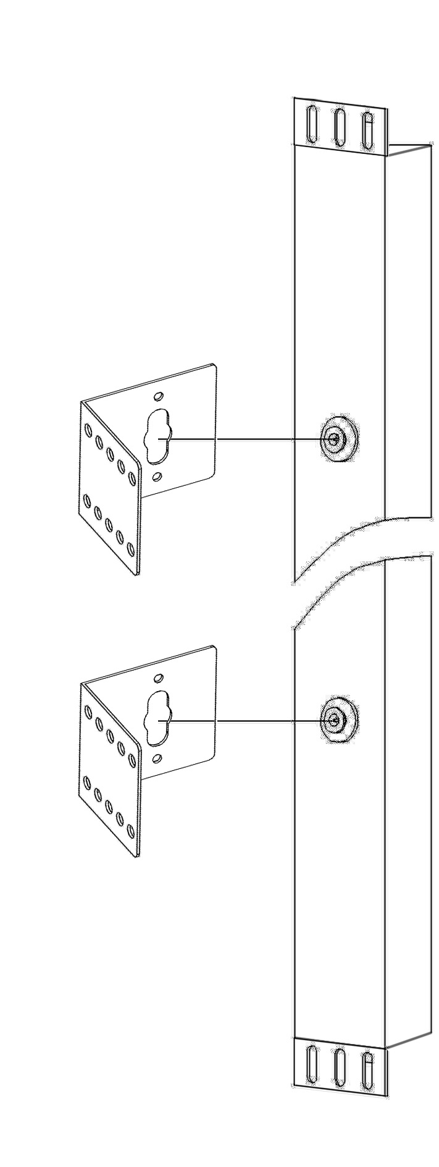 IEC60309 32A 3P+N+E plug

Design：Linda |  |  | Customer confirm: |  |  |  | Check： |  |  |  |  | Authorized：

